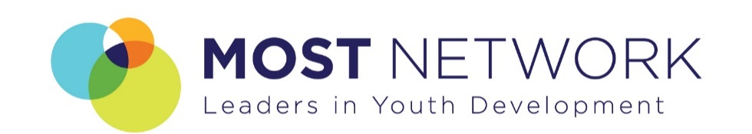
2022 Legislative Agenda
III. Cannabis Legalization with Dedicated Youth Development Spending
Recreational cannabis legalization has been one of the most well-documented public policy experiments in the United States over the past decade. 18 states have fully legalized marijuana consumption, with another 13 approving it for medical use since 2012. The trend towards full legalization nation-wide is clear, and many legislators in Maryland are looking to adopt similar drug policies in the coming election cycle. MOST Network supports these efforts provided they are paired with dedicated spending on youth development initiatives and expanded learning programs.
Today, the damaging social effects of punitive drug policies are well-understood. A marijuana possession charge can have devastating socioeconomic consequences for any offender, but this is especially true regarding young people and people of color. Drug convictions follow offenders long after they’ve served their sentence, as those with a criminal record face barriers to receiving student financial aid, stable housing, and employment. Even after the Maryland General Assembly decriminalized marijuana 2014, thousands were arrested on possession charges, with over 90% of those convicted being young black men. Decades of “zero-tolerance” strategies have yielded little in terms of curbing marijuana consumption and, at worst, have directly sustained an unregulated black market for cannabis products. A new approach to drug addiction is sorely needed, and ending policies associated with the failed “War on Drugs” is a necessary first step.
Meanwhile, states that have legalized, regulated, and taxed cannabis markets have generated enormous public revenues at little social cost. In Massachusetts, a state with comparable demographics and standards of living to Maryland, cannabis retail sales exceeded $1 billion last year, generating nearly $500 million in total cannabis tax revenues. In Massachusetts and other states, cannabis-related tax revenues have been explicitly earmarked for use by state and local education agencies. We argue that Maryland’s cannabis policies should go farther in this respect, using tax revenues generated by the sale of legal cannabis products to sustain out-of-school time programming.
Support for marijuana legalization in Maryland has grown considerably over the past decade, with a commanding majority of Marylanders now saying they would support full legalization. It is past time to let Maryland voters weigh in on the cannabis question through a public referendum.

